1. Explain lack of flow control with UDP.
Ans -
udpcliserv/dgcliloop1.c
1 #include "unp.h"

2 #define NDG 2000 /* datagrams to send */
3 #define DGLEN 1400 /* length of each datagram */

4 void
5 dg_cli(FILE *fp, int sockfd, const SA *pservaddr, socklen_t servlen)
6 {
7 int i;
8 char sendline[DGLEN];

9 for (i = 0; i < NDG; i++) {
10 Sendto(sockfd, sendline, DGLEN, 0, pservaddr, servlen);
11 }
12 }
udpcliserv/dgecholoop1.c
1 #include "unp.h"

2 static void recvfrom_int(int);
3 static int count;

4 void
5 dg_echo(int sockfd, SA *pcliaddr, socklen_t clilen)
6 {
7 socklen_t len;
8 char mesg[MAXLINE];

9 Signal(SIGINT, recvfrom_int);

10 for ( ; ; ) {
11 len = clilen;
12 Recvfrom(sockfd, mesg, MAXLINE, 0, pcliaddr, &len);

13 count++;
14 }
15 }

16 static void
17 recvfrom_int(int signo)
18 {
19 printf("\nreceived %d datagrams\n", count);
20 exit(0);
21 }

2. Important functions of UDP echo server.
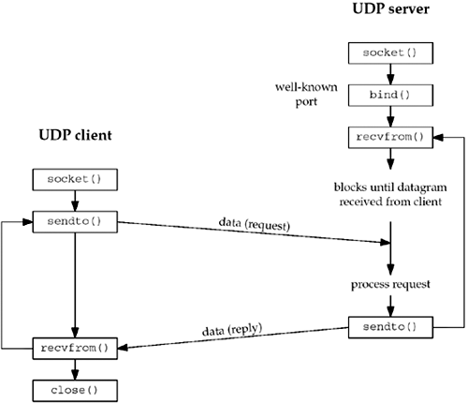
.

3.Steps involved in building an echo Client-Server application using UDP.
UDP Server :

Create a UDP socket.
Bind the socket to the server address.
Wait until the datagram packet arrives from the client.
Process the datagram packet and send a reply to the client.
Go back to Step 3.
UDP Client :

Create a UDP socket.
Send a message to the server.
Wait until response from the server is received.
Process reply and go back to step 2, if necessary.
Close socket descriptor and exit.
Necessary Functions :

int socket(int domain, int type, int protocol)
Creates an unbound socket in the specified domain.
Returns socket file descriptor.
Arguments :
domain – Specifies the communication
domain ( AF_INET for IPv4/ AF_INET6 for IPv6 )
type – Type of socket to be created
( SOCK_STREAM for TCP / SOCK_DGRAM for UDP )
protocol – Protocol to be used by the socket.
0 means use default protocol for the address family.

int bind(int sockfd, const struct sockaddr *addr, socklen_t addrlen)
Assigns address to the unbound socket.

4.The dg_echo function in C that is used in UDP echo server application.

Ans )
lib/dg_cli.c
1 #include "unp.h"
2 void
3 dg_cli(FILE *fp, int sockfd, const SA *pservaddr, socklen_t servlen)
4 {
5 int n;
6 char sendline[MAXLINE], recvline[MAXLINE + 1];
7 while (Fgets(sendline, MAXLINE, fp) != NULL) {
8 Sendto(sockfd, sendline, strlen(sendline), 0, pservaddr, servlen);
9 n = Recvfrom(sockfd, recvline, MAXLINE, 0, NULL, NULL);
10 recvline[n] = 0; /* null terminate */
11 Fputs(recvline, stdout);
12 }
13 }

Our client has not asked the kernel to assign an ephemeral port to its socket. (With a TCP client, we said the call to connect is where this takes place.) With a UDP socket, the first time the process calls sendto, if the socket has not yet had a local port bound to it, that is when an ephemeral port is chosen by the kernel for the socket. As with TCP, the client can call bind explicitly, but this is rarely done.

As with the server function dg_echo, the client function dg_cli is protocol-independent, but the client main function is protocol-dependent. The main function allocates and initializes a socket address structure of some protocol type and then passes a pointer to this structure, along with its size, to dg_cli.

5. Unconnected and Connected UDP sockets.
An unconnected UDP socket, the default when we create a UDP socket
• A connected UDP socket, the result of calling connect on a UDP socket

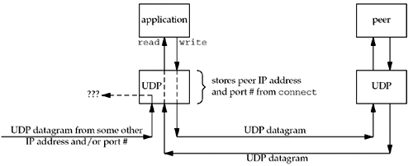

6. Identify the resulting changes with a connected UDP socket compared to default connected UDP socket?

With a connected UDP socket, three things change, compared to the default unconnected
UDP socket:
1.
We can no longer specify the destination IP address and port for an output operation.
That is, we do not use sendto , but write or send instead. Anything written to a
connected UDP socket is automatically sent to the protocol address (e.g., IP address
and port) specified by connect .
Similar to TCP, we can call sendto for a connected UDP socket, but we cannot specify
a destination address. The fifth argument to sendto (the pointer to the socket address
structure) must be a null pointer, and the sixth argument (the size of the socket
address structure) should be 0. The POSIX specification states that when the fifth
argument is a null pointer, the sixth argument is ignored.
2.
We do not need to use recvfrom to learn the sender of a datagram, but read , recv ,
or recvmsg instead. The only datagrams returned by the kernel for an input operation
on a connected UDP socket are those arriving from the protocol address specified in
connect . Datagrams destined to the connected UDP socket's local protocol address
(e.g., IP address and port) but arriving from a protocol address other than the one to
which the socket was connected are not passed to the connected socket. This limits a
connected UDP socket to exchanging datagrams with one and only one peer.
Technically, a connected UDP socket exchanges datagrams with only one IP address,
because it is possible to connect to a multicast or broadcast address.
3.
Asynchronous errors are returned to the process for connected UDP sockets.
The corollary, as we previously described, is that unconnected UDP sockets do not
receive asynchronous errors.

7. Different Interface models that are used in SCTP protocol.

Ans-

There are two types of SCTP sockets: a one-to-one socket and a one-to-many socket

One-to-One Style
The one-to-one style was developed to ease the porting of existing TCP applications to SCTP. It provides nearly an identical model to that described in Chapter 4. There are some differences one should be aware of, especially when porting existing TCP applications to SCTP using this style.

-Any socket options must be converted to the SCTP equivalent. Two commonly found options are TCP_NODELAY and TCP_MAXSEG. These can be easily mapped to SCTP_NODELAY and SCTP_MAXSEG.

-SCTP preserves message boundaries; thus, application-layer message boundaries are not required.

-Some TCP applications use a half-close to signal the end of input to the other side. To port such applications to SCTP, the application-layer protocol will need to be rewritten so that the application signals the end of input in the application data stream.

-The send function can be used in the normal fashion. For the sendto and sendmsg functions, any address information included is treated as an override of the primary destination address

One-to-Many Style
The one-to-many style provides an application writer the ability to write a server without managing a large number of socket descriptors. A single socket descriptor will represent multiple associations, much the same way that a UDP socket can receive messages from multiple clients.

`When the client closes the association, the server side will automatically close as well, thus removing any state for the association inside the kernel.

Using the one-to-many style is the only method that can be used to cause data to be piggybacked on the third or fourth packet of the four-way handshake (see Exercise 9.3).

Any sendto, sendmsg, or sctp_sendmsg to an address for which an association does not yet exist will cause an active open to be attempted, thus creating (if successful) a new association with that address.

The user must use the sendto, sendmsg, or sctp_sendmsg functions, and may not use the send or write function. (If the sctp_peeloff function is used to create a one-to-one-style socket, send or write may be used on it.)

Anytime one of the send functions is called, the primary destination address that was chosen by the system at association initiation time (Section 2.8) will be used unless the MSG_ADDR_OVER flag is set by the caller in a supplied sctp_sndrcvinfo structure.

8. sequence diagram to indicate the functioning of 4-way handshake for the establishment of an association in SCTP protocol.
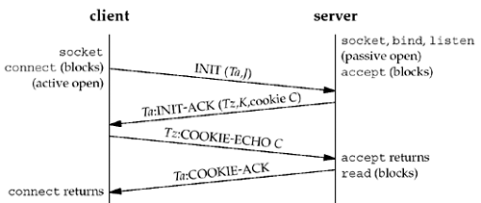

9. Steps that allow an IPv4 TCP client to communicate with IPv6 server using dual stack.

Dual-Stack Routers: In dual-stack router, A router’s interface is attached with IPv4 and IPv6 addresses configured are used in order to transition from IPv4 to IPv6.
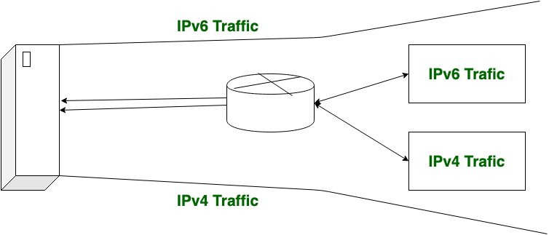

10. syslogd daemon. Indicate with code snippet, how to call the syslog function.
11. Write a pgm to echo message using UDP

